3 cеместр
Тема: Aerospace industry modern environmental technologies and eco-friendly materials (in manufacturing aircraft.)
Warm up https://youtube.com/shorts/1VcN70na93c?si=NMEMzqX6T_WK3Rcv
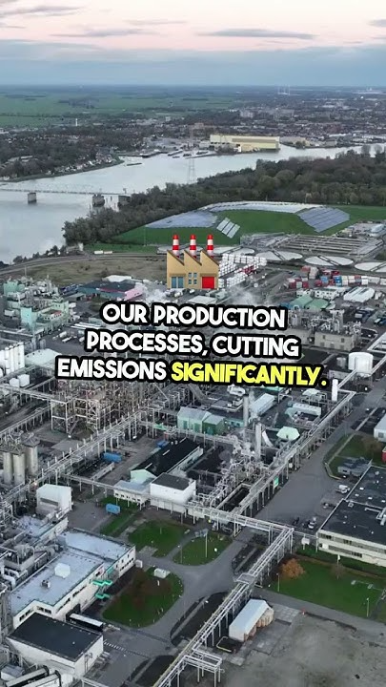
Task 1 Watch the video and highlight the main ideas.

- How is aviation connected with environmental issues?
- What are the way to reduce environmental impact of aerospace industry?
- How can we make aviation more environmentally friendly?
Task 2 Read the text paying special attention to the vocabulary, write down words and phrases in bold. Make sure you know their meaning.

Some technology trends driving change in aerospace industry
As the aerospace industry is facing increasing pressure to reduce its environmental impact, it aims to mitigate it, reduce its carbon emissions and embrace eco-friendly practices throughout the entire lifecycle of aerospace products and operations. As the world becomes more conscious of the importance of combatting environmental harm, the aerospace sector recognizes the need to adopt sustainable practices to ensure long-term viability.
Developing environmental technologies and eco-friendly materials the aerospace industry contributes to sustainable aviation. Some key areas of focus include:

Sustainable Aviation Fuels. Biofuels.

Currently, the aerospace industry relies heavily on fossil fuels. The aerospace industry emits close to one billion metric tons of carbon dioxide yearly, with the figures projected to triple by 2050. The industry is under constant pressure to review its operations and implement innovative technologies to minimize greenhouse gas emissions.
On a larger scale, airlines are investigating sustainable aviation fuels (SAFs) made from renewable sources like biofuels or synthetic fuels as an alternative to conventional jet fuel.
These fuels have similar chemical characteristics as fossil fuels but with fewer ozone depletion capabilities — they release carbon that has already been extracted from the environment. Emissions from SAFs have a shorter life cycle reducing their Ozone depletion rates further.
The so called biofuels derived from non-food sources can be produced from diverse plant and animal materials, algae, and food waste. Companies like Boeing and Airbus are investing in biofuel research and have successfully tested various biofuel blends in commercial flights.
SAFs reportedly have the potential to significantly reduce greenhouse gasses long-term, decreasing flight emissions by up to 94 percent.
Improved air travel management
The aviation industry is also trying to enhance sustainability by limiting fuel consumption in general. Airlines are cutting down on operational emissions by finding time-efficient flight routes. Some airlines still use old air travel management systems, which increases inefficiency in route planning and asset management. Airlines can minimize their carbon footprints by digitizing air travel management and leveraging advanced technology to improve route planning and asset maintenance and enhance operational efficiency.
Leveraging advanced technologies — like artificial intelligence — can improve fuel efficiency by simplifying flight path planning, predicting market dynamics, and suggesting routes based on weather conditions. It helps companies to optimize fleet utilization for more economical operations.
Optimized flight path planning implies companies can reduce aircraft mileage, leading to reduced fuel consumption and fewer emissions. They can also digitize customer management at passenger terminals to reduce paperwork and other activities associated with greenhouse gas emissions.
Advanced propulsion technology
Modern and future aircraft will not rely only on fossil-powered engines. The push for sustainable flights is revolutionizing the design of aircraft and spacecraft propulsion systems. Advanced propulsion technologies focus on increased efficiency, better fuel range and higher aircraft performance.
Some advanced propulsion systems include:
● Electric
● Hybrid
● Solar
● Fuel cell
Electric propulsion systems use motors powered by rechargeable batteries. Hybrid systems combine fossil fuels and advanced propulsion systems like electric, hydrogen-powered, and fuel-cell technologies. Advanced propulsion technologies require significant aircraft redesigns to modify power transfer.
Developing advanced propulsion systems requires close collaboration between the aerospace industry and other sectors — like the automotive industry that have made significant strides in battery technology. With these propulsion technologies taking shape, airlines achieve better fuel efficiency and can significantly cut greenhouse gas emissions.
Advanced eco-friendly materials
Lightweight composite materials, particularly carbon fiber reinforced polymers (CFRPs), are transforming aerospace engineering thanks to their exceptional strength-to-weight ratio and resistance to corrosion. Today, about half of the structures in modern aircraft like the Airbus A350 and Boeing 787 Dreamliner utilize CFRPs. This shift not only reduces operating costs but also reduces environmental impact by improving fuel efficiency. However, a significant challenge remains: these composites are difficult to recycle. Once used, many components end up in landfills, highlighting a broader sustainability issue within the industry.
Alongside composites, aluminum alloys such as 7178-T6 and 7079-T6 continue to play a crucial role. These alloys are strong, lightweight, affordable, and easy to machine, making them popular choices. Yet, their relatively low melting points limit their use in high-temperature environments. Additionally, aluminum’s softness means it wears out faster compared to other metals. As aerospace materials evolve, so too must the methods for machining and tooling to accommodate new composites and alloys.
A promising development is CentrAl, a special aluminum fiber composite developed partly at Delft University of Technology. This material’s unique properties make it nearly immune to metal fatigue, a common issue in aircraft wings. Its use can dramatically improve aircraft energy efficiency, lowering fuel consumption and maintenance costs. Worldwide, such advancements could translate into savings of up to $100 billion, marking a significant step toward greener, more sustainable aviation.
Recycled materials are gaining attention as ways to minimize waste and resource use. Retired aircraft are dismantled to recover valuable materials, but current practices often fall short. This recycling process is crucial for recovering valuable materials and ensuring safety but also presents environmental challenges. Retired aircraft may contain hazardous substances such as lead, asbestos, and various chemicals, which, if not handled properly, can contaminate soil and water.
Not all retired planes are scrapped, however. Some are sold to smaller airlines or converted for cargo use, especially in areas where older aircraft still meet demand. Many are dismantled and recycled, with up to 85% of materials reused in new products. Metals like aluminum and titanium are processed for new applications, while other parts find their way into electronics and other industries. High-value components, including engines and landing gear, are often refurbished and returned to service when their maintenance records are thorough.
One major focus is on using eco-friendly materials in airplane construction. Recycled plastics, such as those from water bottles and wrappers, are being repurposed for cabin elements like seat covers, tray tables, and overhead bins. Similarly, recycled textiles made from polyester, nylon, and other fibers are gaining attention for use in seat covers, curtains, and carpeting. Bamboo stands out as a lightweight, renewable alternative to traditional hardwood, suitable for flooring, paneling, and trim in aircraft cabins. Some innovators are even using bamboo for in-flight meal packaging. Cork, harvested sustainably without harming trees, offers another renewable option for cabin flooring and wall coverings.
Together, these innovations—from eco-friendly cabin materials to sustainable fuels and efficient IFE systems—represent a comprehensive approach to making aviation more environmentally responsible. As the industry continues to adopt these measures, it moves closer to balancing the growing demand for air travel with the urgent need to protect our planet.
Task 3 Read the text again and answer the questions.
- Why is the aerospace industry facing pressure to become more sustainable?
- What are Sustainable Aviation Fuels (SAFs) and how do they contribute to sustainability?
- How can improved air travel management help airlines become more sustainable?
- What are some examples of advanced propulsion technologies being explored in the aerospace industry?
- Why is collaboration important in the development of advanced propulsion technologies for aircraft?
- What are the main advantages of carbon fiber reinforced polymers in modern aircraft design?
- How does the use of lightweight composite materials affect the environmental impact of airplanes?
- What challenge does the aerospace industry face regarding the disposal of composite materials?
- Why do aluminum alloys like 7178-T6 and 7079-T6 remain popular despite the rise of composite materials?
- What limitation of aluminum alloys affects their use in high-temperature parts of aircraft?
Task 4 Watch the video, make a mind map. Working in pairs, discuss the what technologies and strategies exist in aerospace industry today.

https://youtu.be/ldhilLgVML0?si=jiPsDAJTuVoEE9Lv
Additional videos to choose and discuss with your students on the topic.
https://youtu.be/x5hDcmnJBiw?si=EF8LdHKvJoltEfqG
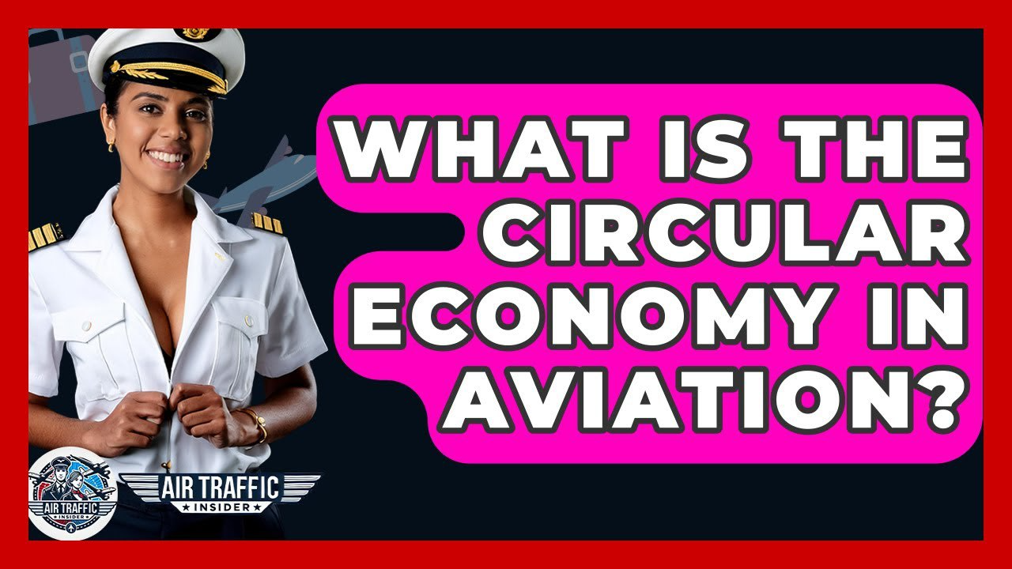

https://youtu.be/rYqUDuQnFvw?si=qABtibS6COPxiLew
